Use of Force Time Series Analysis.
Dallas DeBlasio
4/30/2026
Yin Zhang

Introduction
The use of force by law enforcement is a topic that receives significant public attention because of its impact on community trust, public safety, and police accountability. Understanding how frequently force is used and whether trends change over time can provide valuable insight for both law enforcement agencies and the public. Time-series analysis offers a method for identifying patterns, trends, and potential seasonality in incident data while also creating forecasts for future events. In this report, use-of-force incidents from the WADEPS dataset are analyzed to identify temporal patterns and develop predictive models. By applying forecasting techniques such as ARIMA and XGBoost, the analysis aims to estimate future incident counts and evaluate which modeling approach is better suited for limited and evolving datasets.

Problem definition and context
Use of force is defined as anytime the officer has to take physical action against the subject. We want to be able to track and predict the number of these incidents over time. This will help us understand more about the rate at which force is being used on subjects, and help detect if there is any seasonality in our dataset. This gives the public a better idea of how police interactions usually go, and lets them see the rate at which we expect use of force to rise as time goes on. Furthermore, we want to develop a model that may be able to predict the number of incidents of force for the coming weeks so that officers can be better prepared when responding to calls.

Data Overview and Cleaning
To address the questions, I utilized the WADEPS use-of-force dataset. This dataset is publicly available on their website and was created to improve public safety, transparency, and oversight. All entries to the dataset are cases where an officer used force on a subject. At the time of this report, the data has 215 columns and 1058 rows. Additionally, a data library can be found on the site to better understand all the columns. The key variable used for this analysis is the incident_time. Additionally, other columns in the dataset are in a ‘Y’ or ‘N’ format. The time range of our data is quite small, and it is a dataset that is being constantly updated. That means all analyses performed in this report require the exact time ranges for reproducibility.

Methology
To make the time-series analysis, we wanted models that would work best with our dataset. The constraints that we currently have on the time range of our data are a big limitation for most models. That led us to use the ARIMA model for our predictions. In order to find the most optimal values for the ARIMA model, an ADF test was implemented alongside an autocorrelation and partial-autocorrelation graph. It appears to be the models that can adjust the best to the lack of data. SARIMA was also considered for the project, but the lack of data makes it difficult to accurately track the seasonal changes that SARIMA accounts for. Additionally, an XGBoost model was implemented for comparison with the ARIMA model. The biggest drawback for both of these models is the high chance of overfitting due to our small dataset.

Models
When building the model, we started by uploading our dataset and filtering by date range. This is crucial because data has not been entered consistently for the lifespan of the dataset. Cutting date ranges that don’t have consistent entries is important because otherwise, we are training the model with incomplete and missing data. The date range chosen was from August 25, 2025, to February 21, 2026. Once we have the date range, we run ADF to test if the data is stationary. In our case, we get a p-value of 0.041, so we can reject the null hypothesis and claim the data is stationary. This means our d value for the model will be 0. Additionally, the autocorrelation and partial autocorrelation graphs both showed a spike at 1, meaning our p and Q values will each be 1 (see figure below).
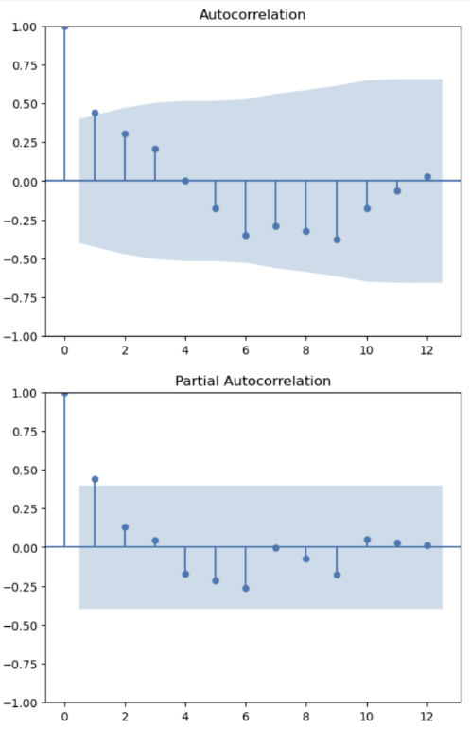

With that, we can start building our ARIMA model. We took the filtered dataset and trained the model, and then compared it with the actual number of incidents reported for those weeks. This led to an accurate model despite the data's limitations. Additionally, we wanted to compare the outputs to an XGBoost model. The XGBoost model is a model that uses decision trees and takes the sum of all the trees to make predictions. It was implemented to test if ARIMA would be the best fitting model.
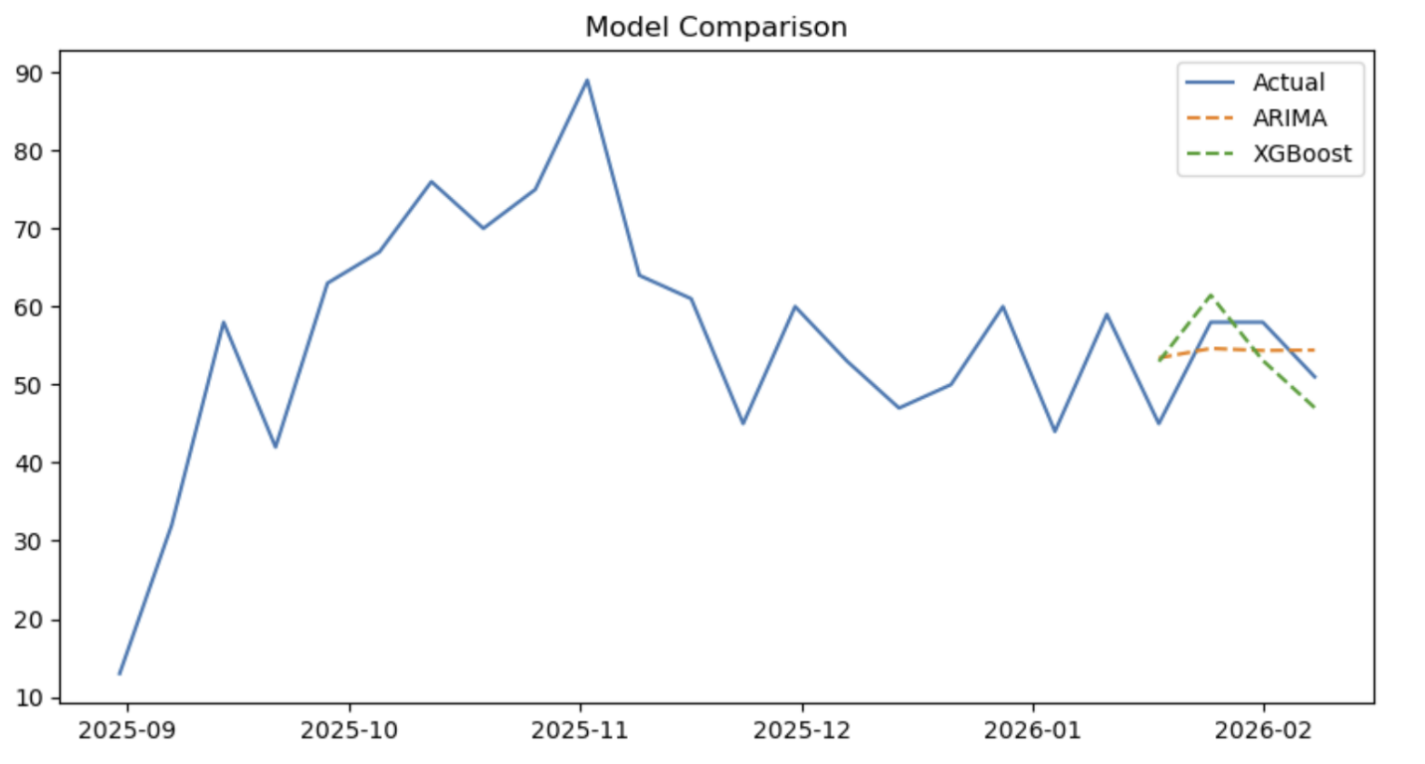
This resulted in an ARIMA root mean square error (RMSE) of 5.17 and a % error of 0.098, and an XGBoost RMSE of 5.36 and a % error of 0.101. The two models performed very similarly, with ARIMA being the slightly better model in this situation. That said, it is important to keep in mind that the dataset is still very small, and as time goes on, this may end up changing.

Results and Recommendations
The results of this analysis suggest that time-series modeling can provide useful insights into use-of-force incident trends, even with a relatively small dataset. Both ARIMA and XGBoost produced comparable results, with ARIMA showing slightly better performance based on RMSE and percentage error metrics. The stationarity of the data and autocorrelation patterns supported the use of an ARIMA(1,0,1) model, which appeared to adapt effectively despite the dataset's limitations. However, the narrow time range and ongoing updates to the dataset create challenges, including an increased risk of overfitting and difficulty identifying long-term seasonal patterns.
For future work, collecting additional data over a longer period would likely improve model performance and reliability. A larger time span would also allow for stronger testing of seasonal models such as SARIMA, which may capture recurring patterns not visible in the current dataset. Additionally, incorporating external variables such as crime rates, population trends, weather conditions, or policy changes could strengthen predictive accuracy. As the dataset continues to grow, periodic retraining and evaluation of models is recommended to ensure forecasts remain accurate and reflective of current trends.

